Project Report:
By Ewnetu Abebe
Ethiopia Public Health Institute
National Data Management Center
Data Analytics, Modeling and Visualization Division

I conducted preprocessing and exploratory data analysis (EDA) on the provided dataset (champs.csv) and the decoded variables outlined in table 1. By utilizing Python programming, I read the dataset to determine the number of rows and columns, listed the columns, and renamed them. I also assessed the proportion of missing values in each column. Additionally, I conducted Descriptive Data analysis, including analyzing the frequency and significance of each infant underlying cause for child death, examining the maternal factors contributing to child death, and exploring the distribution of child deaths by case type. I also conducted a correlation analysis, feature engineering, model training, and model evaluation using appropriate metrics. Finally, I visualized the results. In summary, I performed essential machine learning tasks to analyze and model the dataset.
Generally I was performing the following important machine learning tasks:
- Feature Importance’s and Model Selection:
Trained multiple models (LogisticRegression, Support Vector Machine, AdaBoostClassifier, Random Forest Classifier, Gradient Boosting Classifier and XGBOOST) and an ensemble model.
Extracted and ranked feature importance’s for each model. Selected the best performing model based on cross-validation and evaluation on test data.
- Model Evaluation Metrics:
  - Imported evaluation metric packages (accuracy score, precision score, recall score, f1_score, confusion_matrix, classification_report, roc_auc_score).
  - Calculated accuracy scores for individual models and the ensemble model.
- ROC Curve and AUC Analysis:
Plotted the ROC curve and calculated the AUC score for each model and the ensemble model.

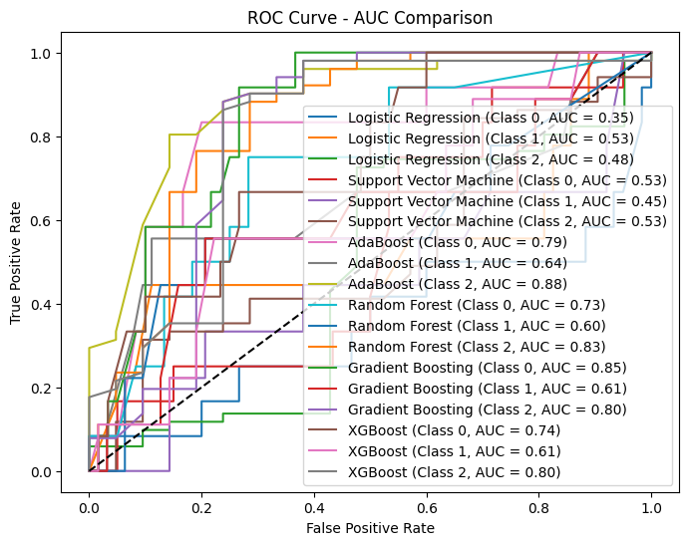
Figure 1 AUC and ROC curve of all the models.
Compared the performance of the models based on the AUC metric.
- Feature Importance Visualization: Visualized the feature importance’s in descending order for individual models (LogisticRegression, Support Vector Machine, AdaBoostClassifier, Random Forest Classifier, Gradient Boosting Classifier and XGBOOST) using horizontal bar charts.
- Plotting Top Data Points: Plotted the top data points under a specific column (column one) in a dataset using a bar plot.

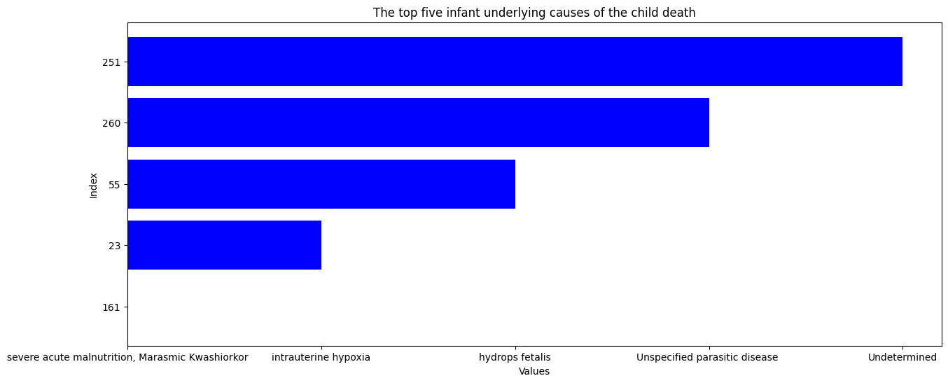
Figure2. Top five infant underlying causes of the child death

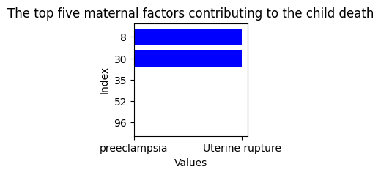
Figure3. The top five maternal factors contributing to the child death

- Plotting Data Frame Based on the Target Variable:
Created plots to visualize the data frame based on the target variable, either categorical or numerical.

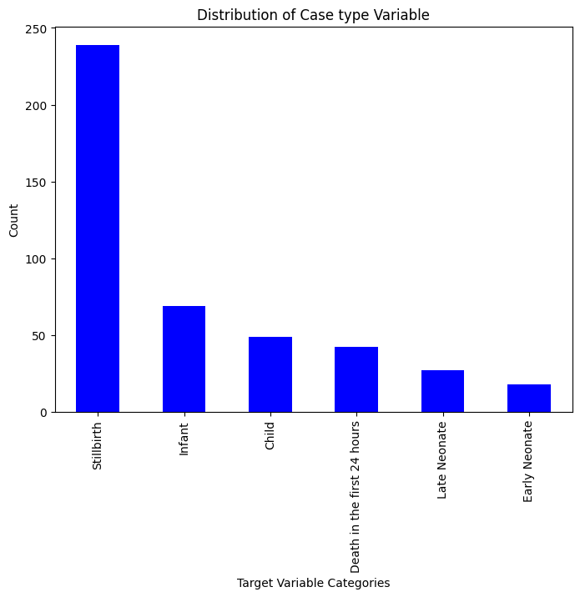
Figure 4. Child death based on the case types
Each of these steps provides insights into the performance, feature importance, and distribution of data in our models. If you would like to see detailed code examples and outputs for each of these reports, please let me know, and I can provide more detailed information.

